**Student Name: Demetrius Johnson**

**Course: CIS450002**

**Professor: Dr. Jinhua Guo**

**Date: April 1, 2022**

**Due Date: April 4, 2022**

**Project 4 Report**

# Lottery Scheduler in xv6:

## Task 1: adding variables to the proc struct in proc.c

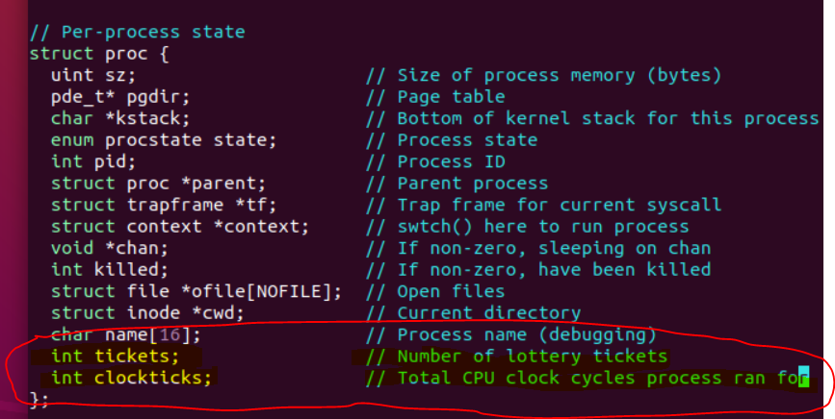

## Task 2: add necessary lines to fork() in proc.c

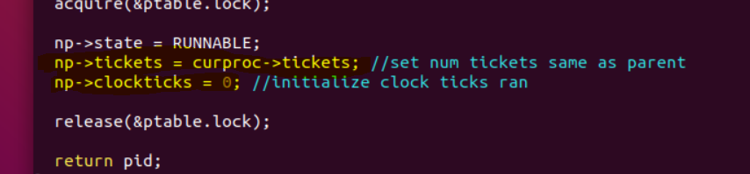

## Task 3: add necessary lines to userinit() in proc.c

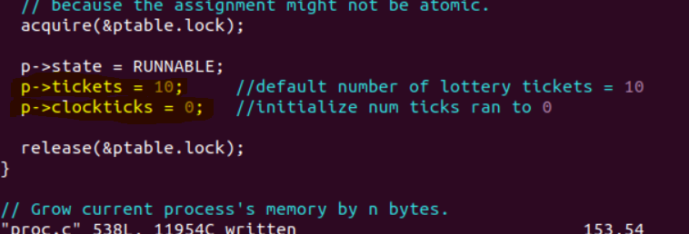

## Task 4: adding the pstat.h file to xv6 directory

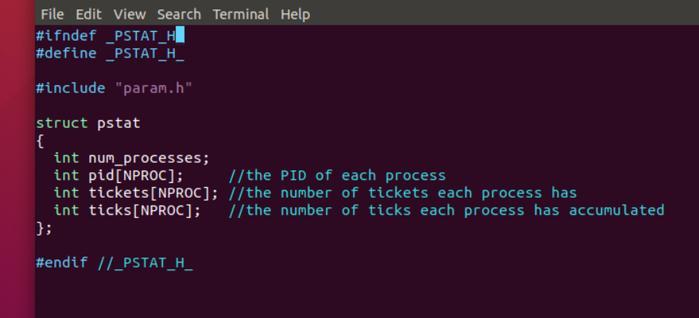

The pstat struct will be used by the provided ps.c function, which calls getpinfo() and passes a reference to the pstat struct it declares to that function 🡪 getpinfo(&pstatStructDeclared);

## Task 5: adding the ps.c file to xv6 directory

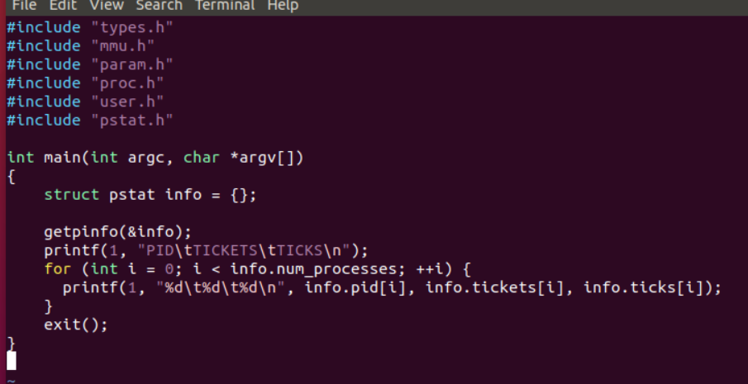

## Task 6: adding random.h and lotteryTest.c file to xv6 directory

Because clipboard couldn’t hold all of the text, I simply added both files to my xv6 directory via direct file copy from my local system to my virtual machine. For the other files provided that I needed to add

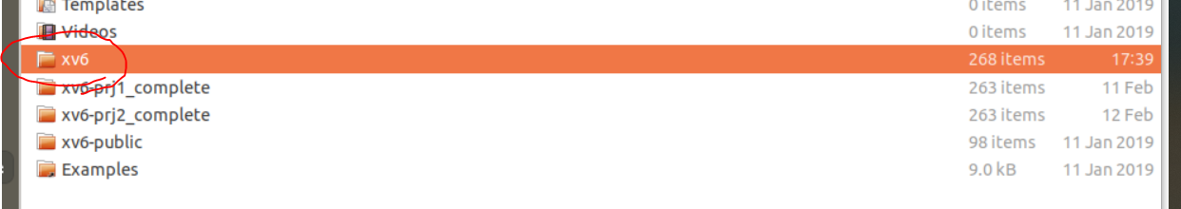

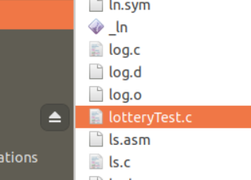

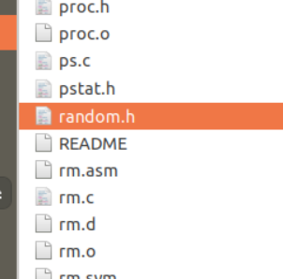

Notice ps.c and pstat.h are also added already from my previous tasks.

## Task 7: writing the settickets() system call

### First, I added the implementation for the kernel-level function in the proc.c file, since proc.c contains all of the libraries/includes and data variables that I need to access for updating the process control block struct, and I want to follow the convention for the other system calls, which are all mostly wrapper functions. In order for the settickets() function written here in proc.c to be seen by the sys_call function I will write in the sysproc.c file, its declaration needs to be added into the defs.h file, which is the declaration file that is included in the main.c file and many other files that are linked with main.c and thus the preprocessor directive makes all function declarations that are defined later in various other files visible:

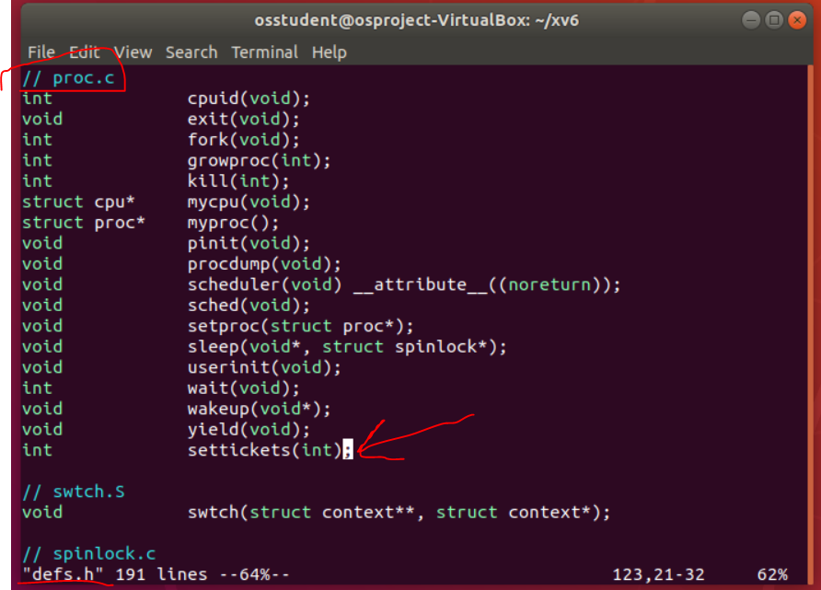

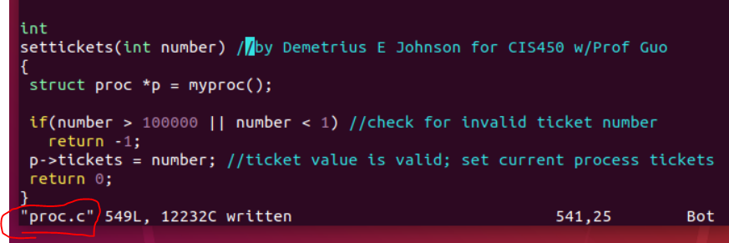

#### Note: defs.h is also included in the sysproc.c file, as well as the proc.c file. However, for our situation, we specifically need the defs.h included in the sysproc.c file, since this is where our sys_settickets() function resides and calls the settickets() function from proc.c:

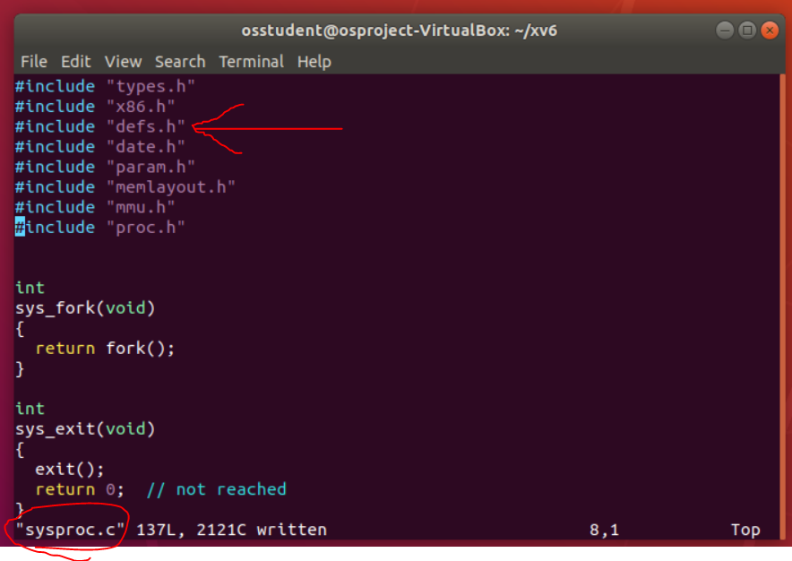

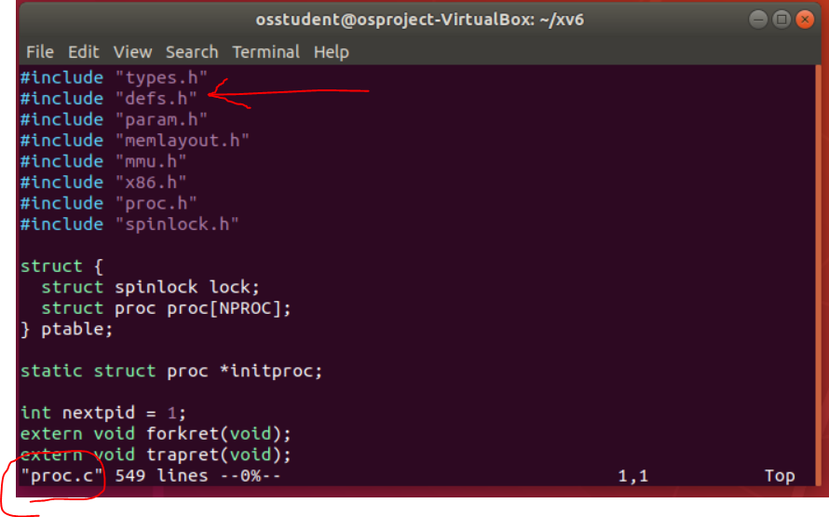

#### As another side note: here are all the files (stored in an array called OBJ) linked to the main.o (the main program) for xv6, specifically the kernel; “kernel” is the name given to the executable when all objects from OBJ array are linked:

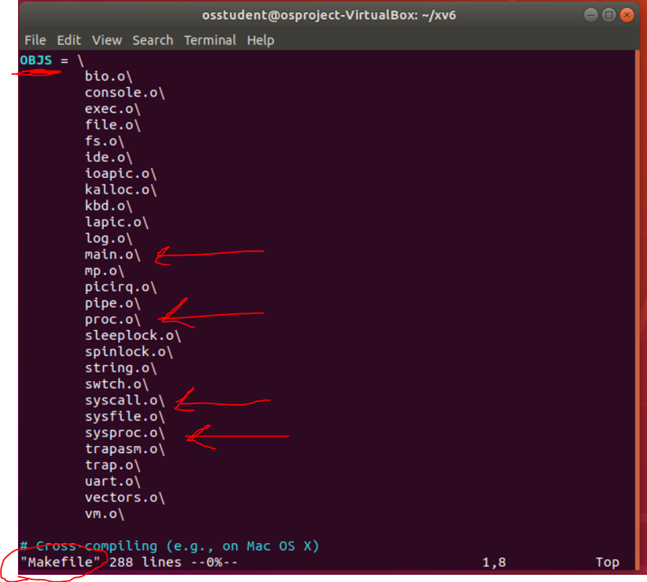

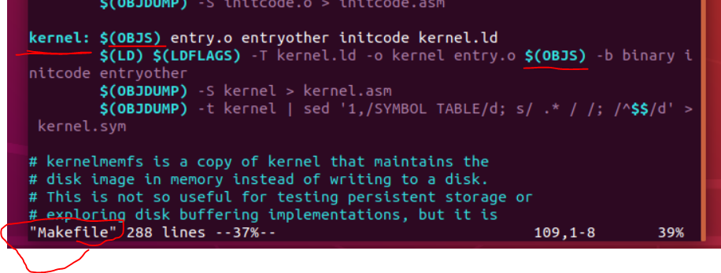

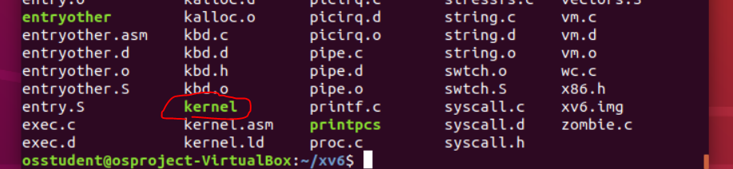

### Now, I add the system call name to the usys.S file so that calling user function can interface with the system call (switching from the call in user.h to this call, which will lead to kernel mode and the kernel sys_call function in sysproc.c):

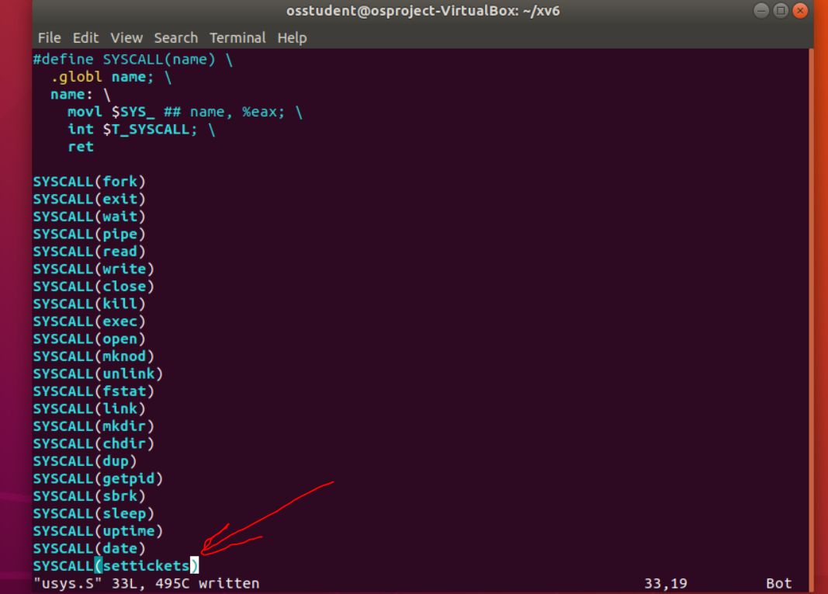

### Now, add the system call to user.h file, which is not actually an implemented function, but rather transfers control from user mode to kernel mode and calls the associated system call function:

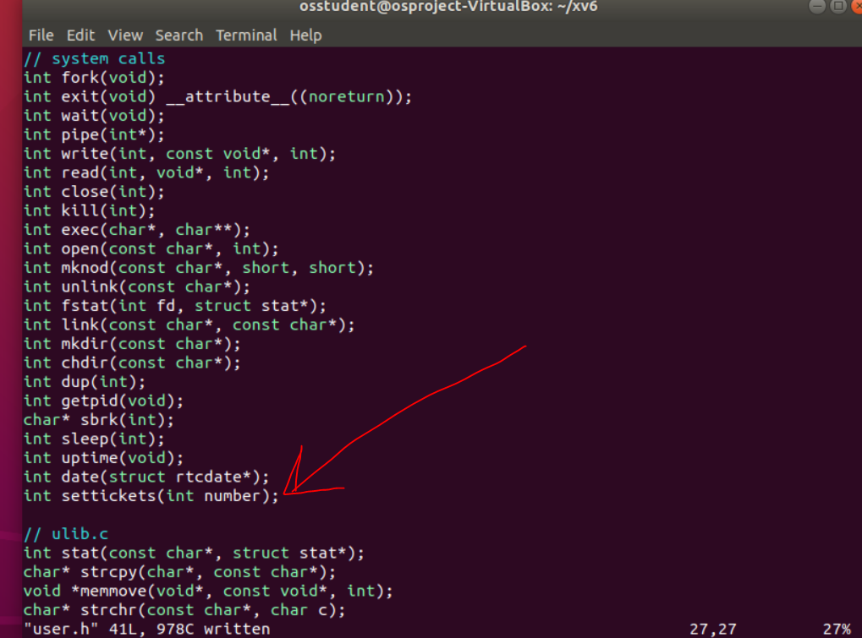

### Now, define set tickets system call value in syscall.h file, which give the associated index value (in this case 23) for indexing into the function pointer array in syscall.c:

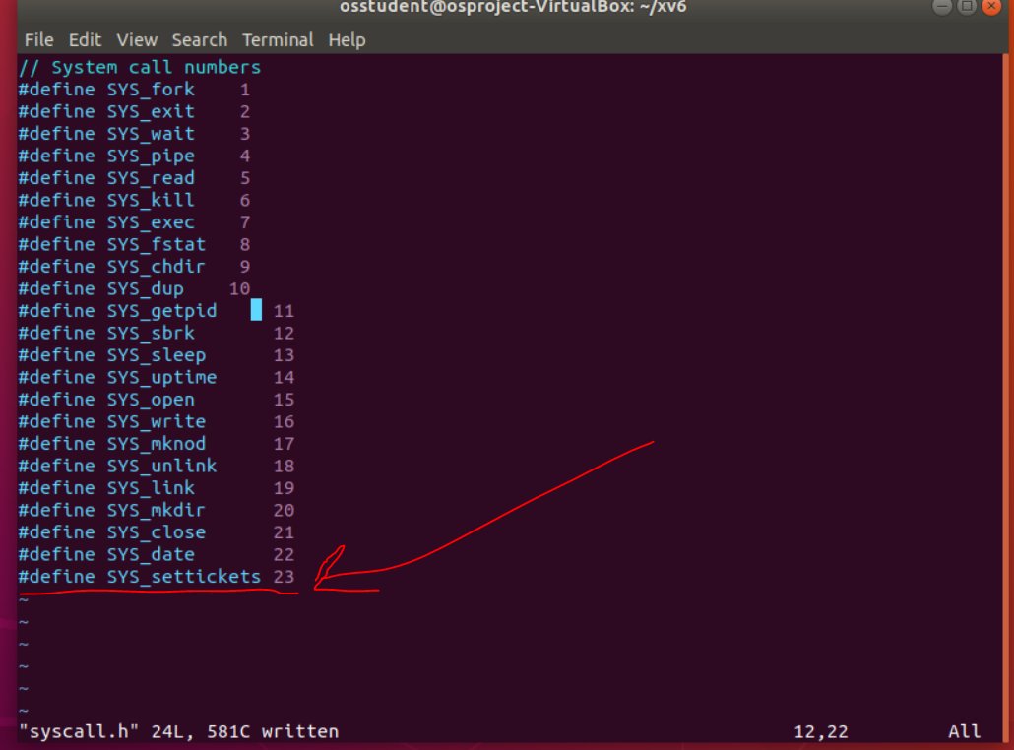

### Then, define an external function and assign the value we added from the previous step (SYS_settickets == 23) to the syscalls[] array – both of these are done in syscall.c file:

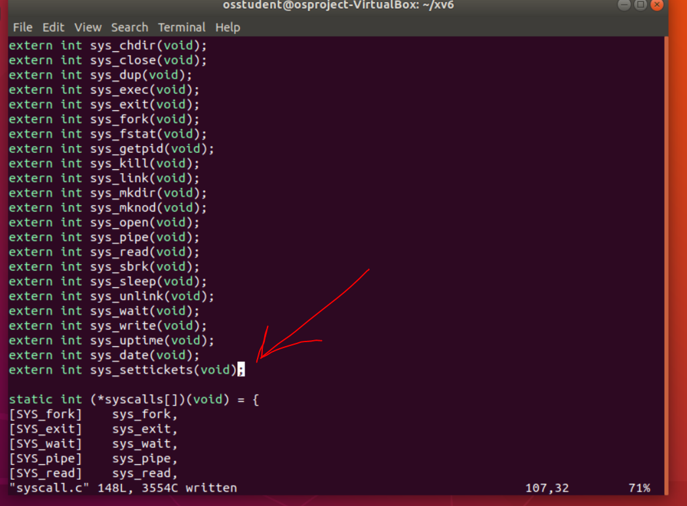

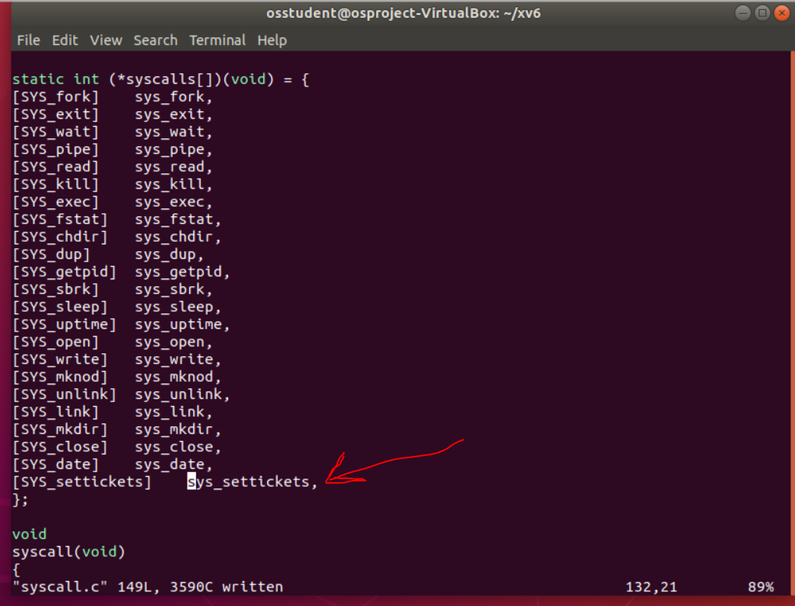

### Now, I write the sys_settickets system call that the user function calls. For this function, I simply acquire the argument passed by the user function (from user.h function) using the argint() function, and then make this system call a wrapper function (following the convention of most of the other system calls) by calling the settickets() function from the proc.c file and returning its value. As a side note, when the user.h function is called that leads to the actual system call, the arguments passed to it are saved in registers so that they can be acquired by the sys_call function.

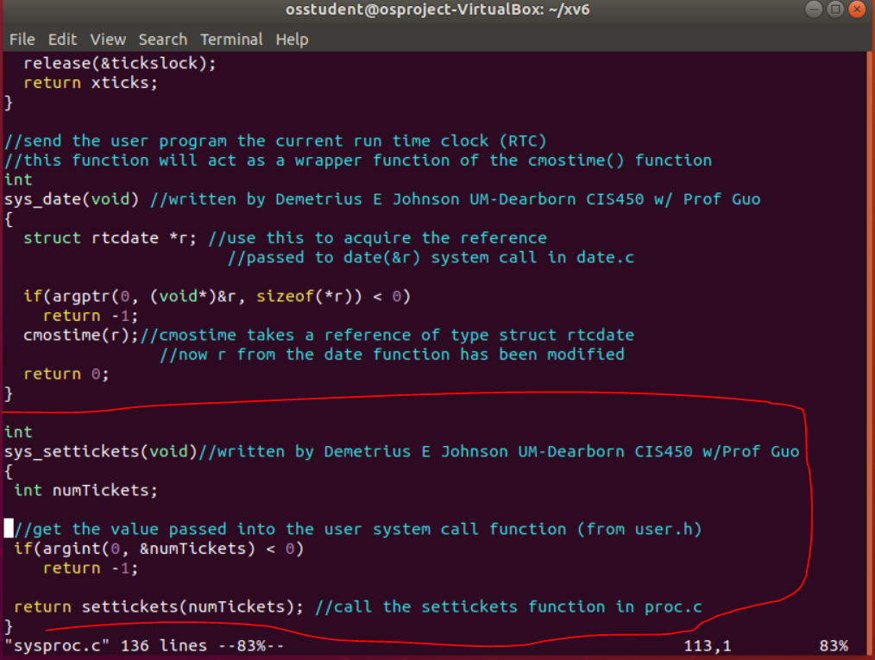

## Task 8: adding entries to the Makefile so that lotteryTest.c and ps.c programs will be available as user programs

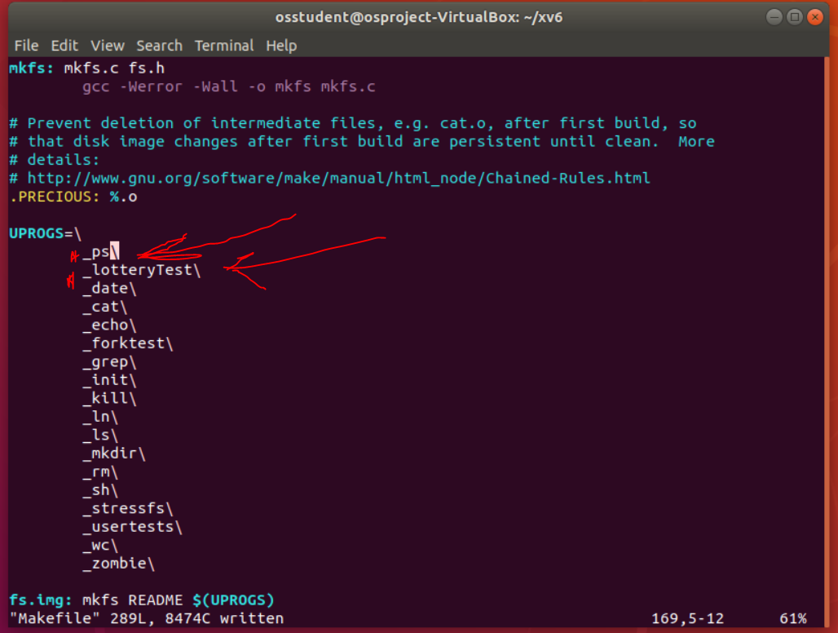

## Task 9: writing the getpinfo() system call

### Essentially, I follow the same steps as with adding the settickets() system call; first I add the declaration to defs.h:

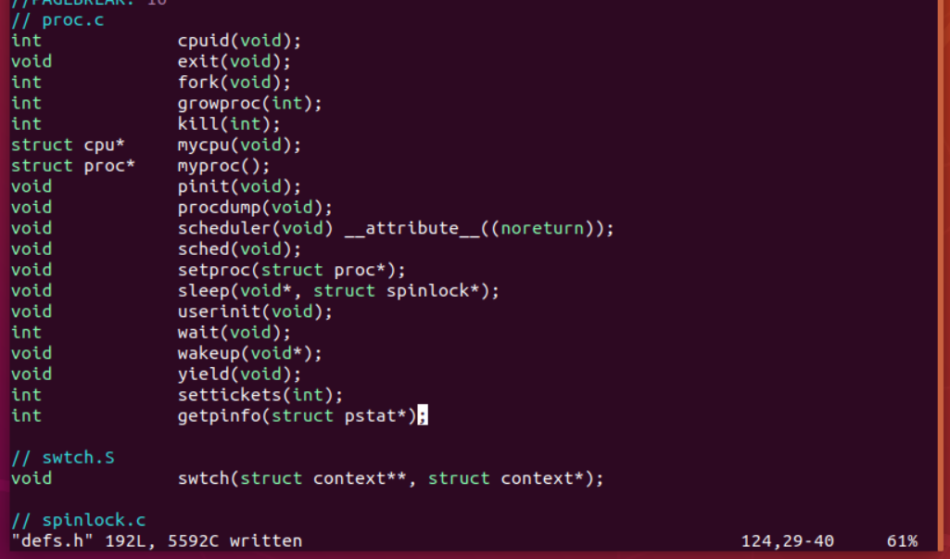

### Add my implementation of getpinfo in proc.c. Again, my sys_call will just be a wrapper function; it will just pass the parameter to this function in proc.c:

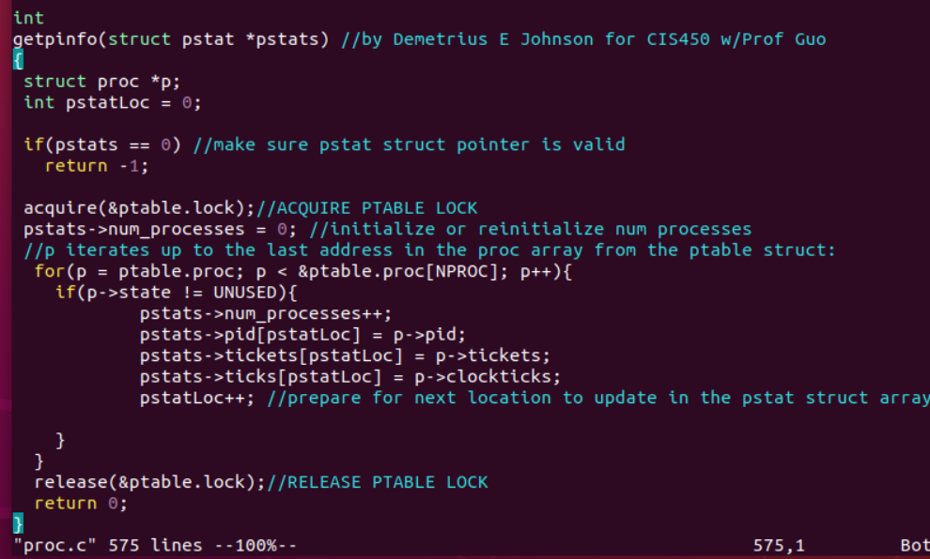

### Update usys.S

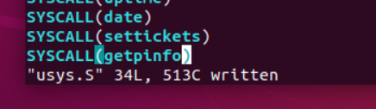

### Update user.h, adding the new system call function and giving pstat struct declaration so that the function knows about such data structure:

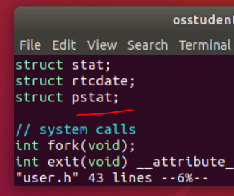

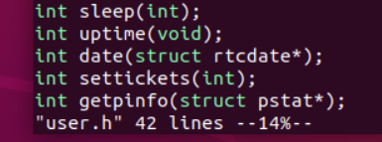

### Update syscall.h and syscall.c

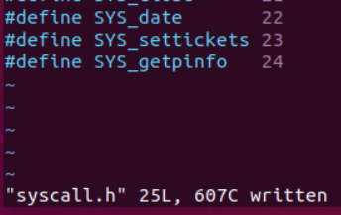

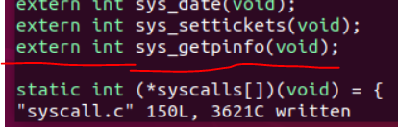

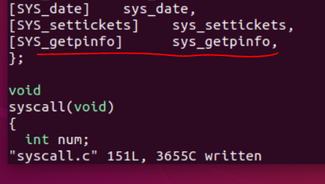

### Update sysproc.c; write the sys_call function, which I made as just a wrapper function:

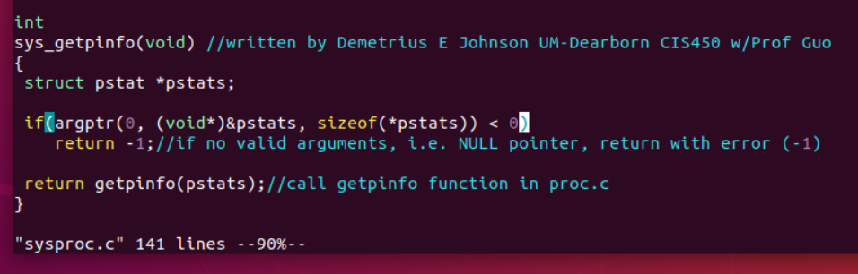

### Update sysproc.c, proc.c, and defs.h to include pstat.h file so that they can see the definition of the pstat struct that used in their respective file (and update main to include it too just in case I end up using the struct in main later!)

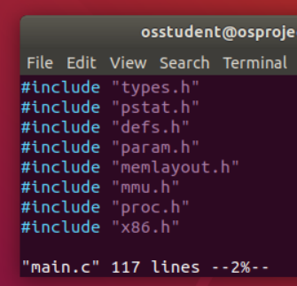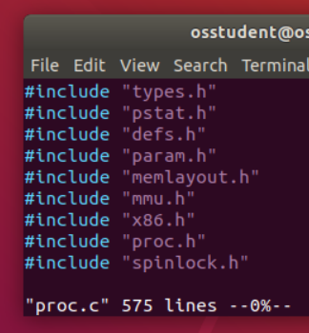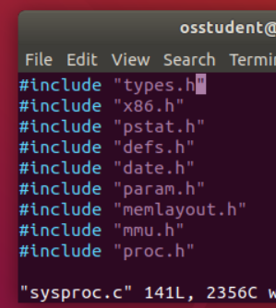

### Update defs.h file, which needs the declaration of the struct that it uses:

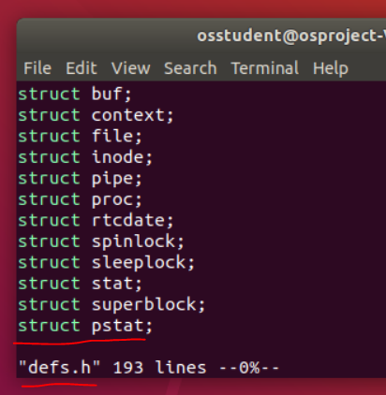

### Update ps.c to output more information (which will be useful to make sure it is working). I added some printf() lines:

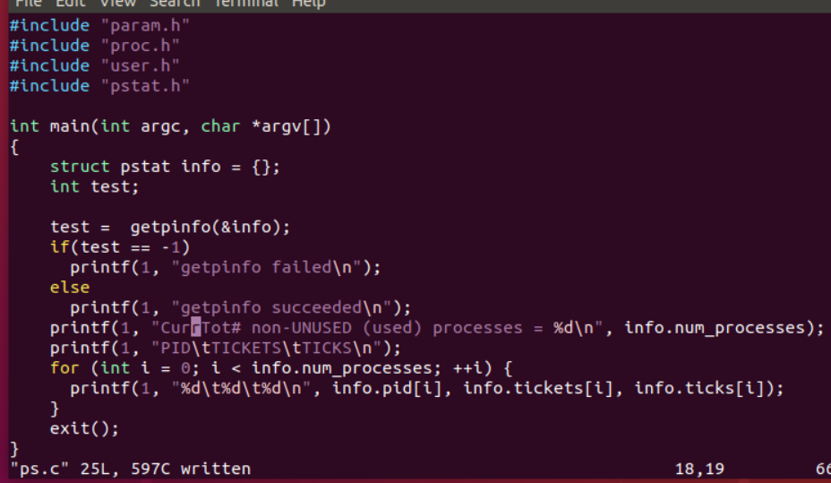

## Task 10: writing the yield() system call

### Update user.h. (Note: this will be another wrapper function, and a very simple system call to add):

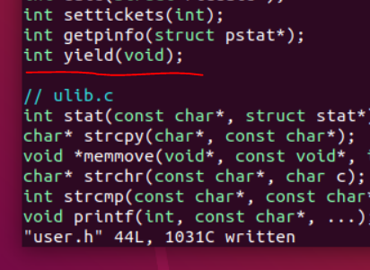

### Update usys.S

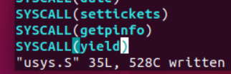

### Update syscall.h

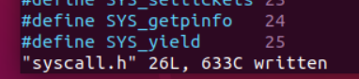

### Update syscall.c

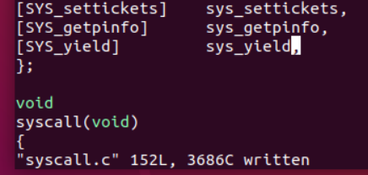

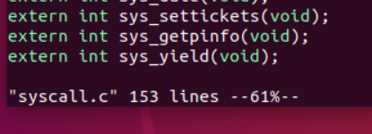

### Update sysproc.c – as you see, again, our sys_call function is just a wrapper function:

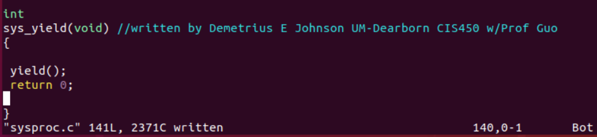

## Task 11: writing the settickets() system call

## Task 12: writing the settickets() system call

# Project Notes (from P4 discussion video)

## General

SUGGESTION – do the program incrementally:

Complete settickets function, TEST ITS FUNCTIONALITY.

Complete getpinfo, TEST ITS FUNCTIONALITY.

Then implement lottery scheduler algorithm.

GO TO PAGE 140 (CHAPTER 9, FIGURE 9.3) IN THE OSTEP (Operating Systems, Three Easy Pieces) book to see implementation of the lottery ticket CPU scheduling.

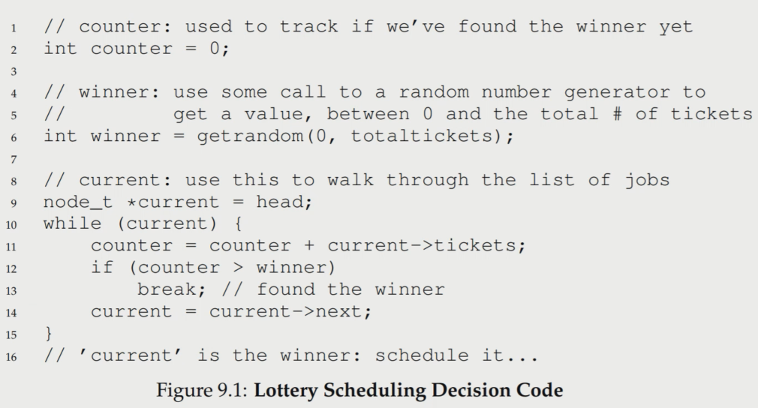

getrandom() generates a random number between 0 and total tickets. A random function is provided for us for this project.

Here is a demonstration of how the lottery scheduling works:

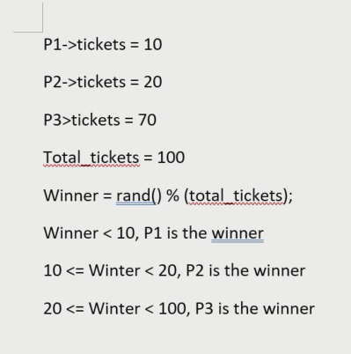

## (proc.h) and (proc.c) file:

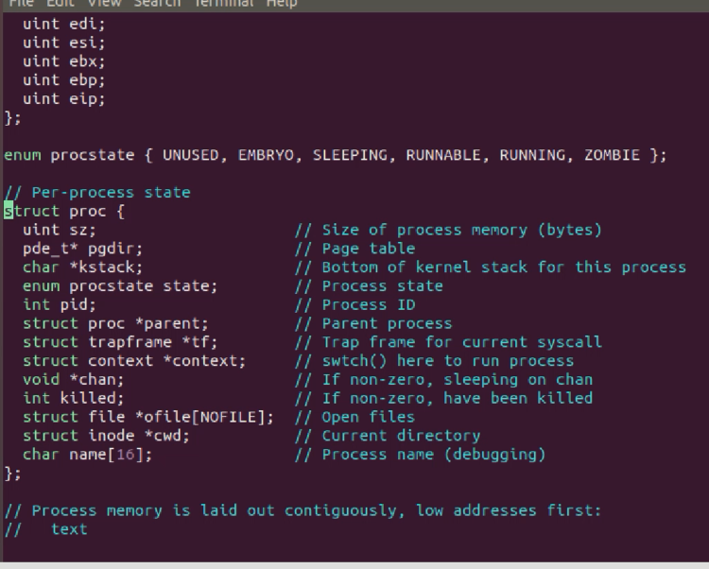

Above is in the proc.h file

It contains the proc (process) struct, which is essentially the process control block (PCB)

For process state enumerator: Sleeping == wait, Runnable == ready, running == running.

context struct saves the necessary registers so that a context switch can occur; saved registers will be reloaded into the proper registers when the process gets assigned to run on a CPU again:

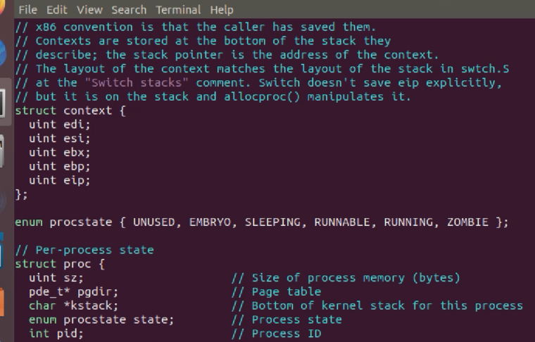

The following lines need to be added to the proc struct:

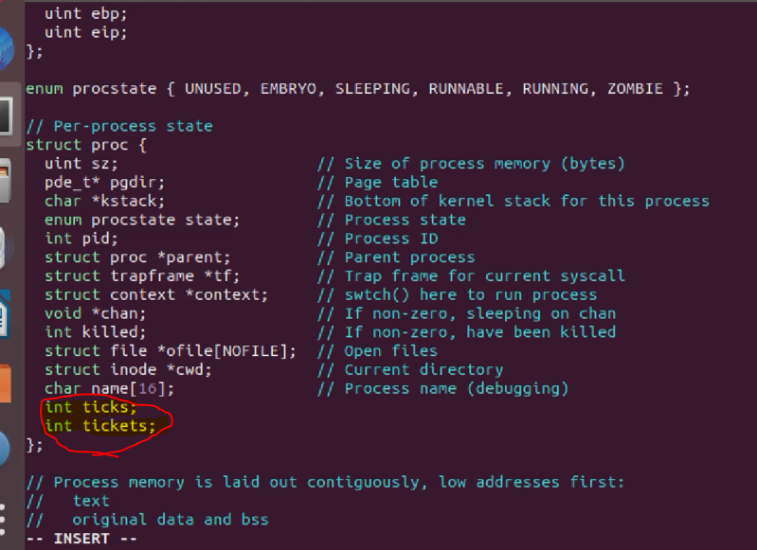

Ticks = number of times a process was scheduled to run on the CPU; each tick (time slice) is about 10ms. Tickets= num tickets assigned to a process.

So for the settickets system call, you just need to update the two added variables in the struct.

## USING THE PS FUNCTION (ps.c):

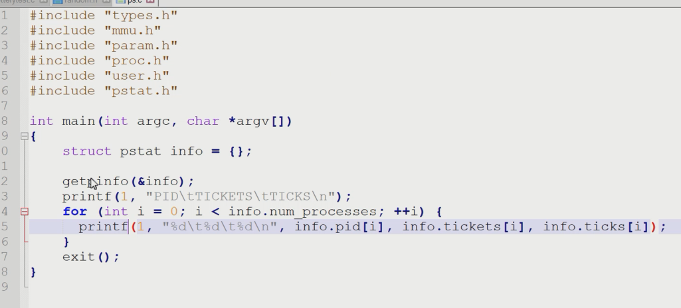

ps() function will call the getpinfo() system call that we must write.

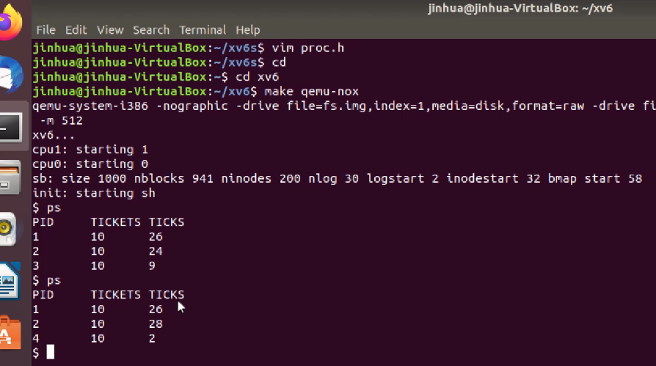

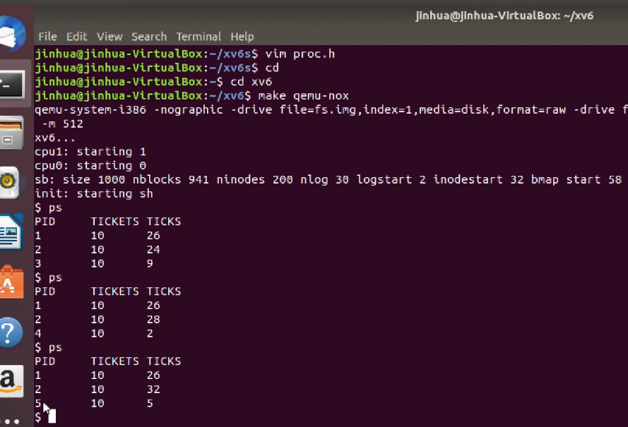

Using the above screenshots for reference, the below two processes will always be running in XV6:

PID 1 is the userinit() process; once it stops, it doesn't really run anymore (although it is not killed) as it is the initial user process and the parent process for the xv6 OS, so ticks (times it was schedule to CPU) will remain mostly static.

PID 2 is the share() process; this process will continue to be ran throughout the life of XV6 running.

Upon first call to ps when you first boot XV6, PID 3 is the ps() function itself; thus when you call ps() again immediately after the first call, you will notice processID 3 is no longer in the system as it has terminated, and now PID 4 is the new call to ps(); etc...

## yield() system call

Need wrapper function for system call: int yield() this is because we simply need to call the already existent xv6 yield() implementation that is a kernel function which thusly cannot be accessed via user mode; hence, we need this simple wrapper system call so that we can switch from user mode to kernel mode and access the kernel level yield() function.

Given scheduler code is in the proc.c and proc.h files; it is round robin; thus we need to simply change it from round robin to lottery scheduling.

## (main.c)

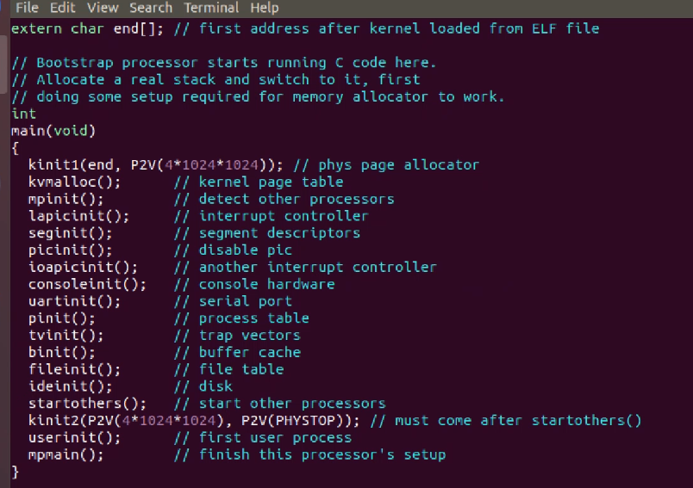

Notice: when we first start XV6, there are a lot of initializations (page tables, etc.).

startothers() function in main.c file for XV6 starts the other processers (if present/available; XV6 uses 2 by default); the lines above that function call are all ran on a single processor.

In main.c for XV6, the first user process ran is called userinit() (in proc.c).

So, first we run OS in kernel mode, then first user process called is userinit().

mpmain() in main.c of XV6 will call scheduler() so that the initial processor can start running processes.

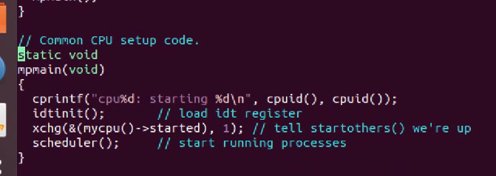

The startothers() function will also end up leading to a call to the scheduler() function so that all subsequent CPUs that start running with the initial CPU will also run the scheduler() function to run processes.

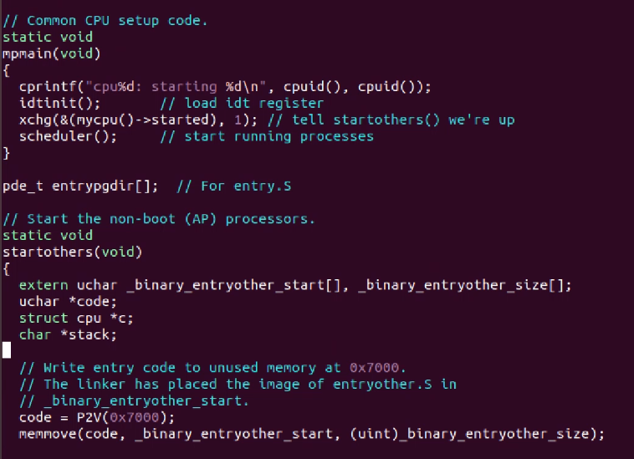

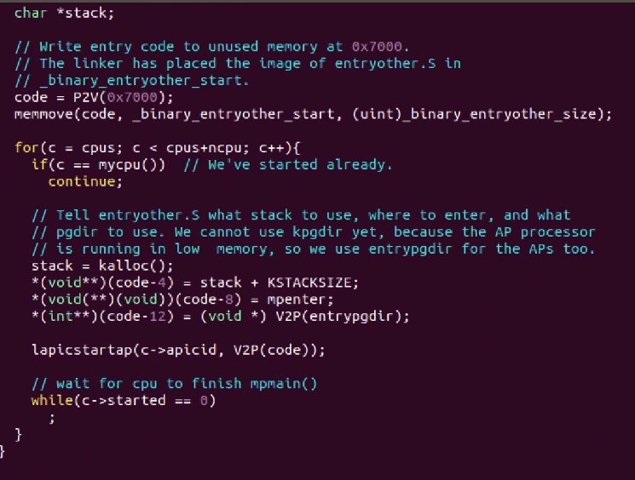

mpenter() will call mpmain():

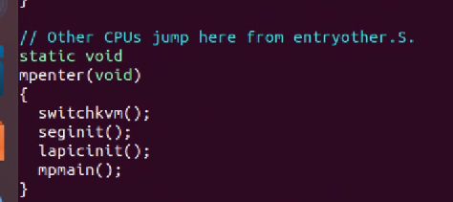

And mpmain() will call scheduler()

So, both CPUs in XV6 will end up calling the scheduler() function to run user processes; after calling the userinit() function, they both will get to the scheduler.

Our job is to change the scheduler() function in the proc.c file from a round robin scheme to lottery.

## In scheduler function from (proc.c) file:

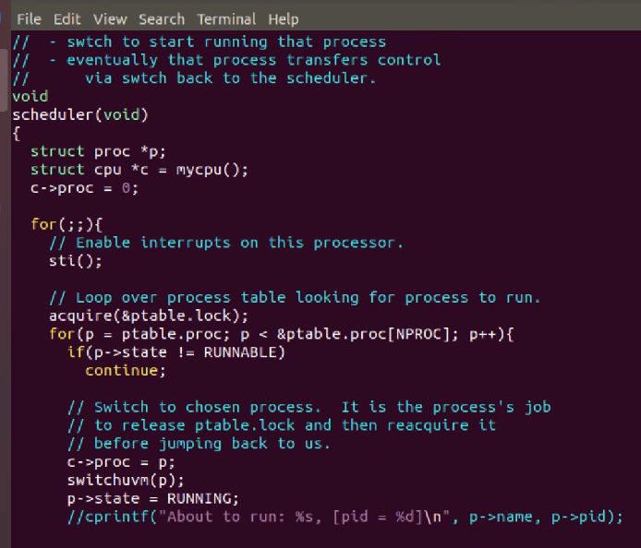

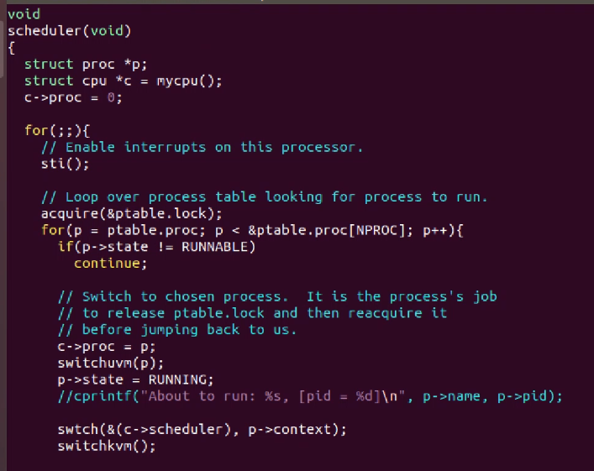

Scheduler is an infinite loop so that any processes that will enter the system can then start to be ran by the CPU via the scheduler() function. So each CPU will stay in this scheduler loop (continue running it) forever until the system is shutdown/rebooted.

mycpu() function returns which CPU is accessing the scheduler function; returns an int (0 = cpu0, 1 = cpu1).

switchuvm() function switches the page table from kernel page table to the current user process page table – uvm perhaps stands for “user virtual memory”.

Then, process state changed from runnable to running.

Then, swtch() is called – it is written in assembly language directly, and is in the swtch.S file; which performs a context switch, which switches from the current kernel process that is running (c🡪scheduler()) to the chosen user process (p🡪context).

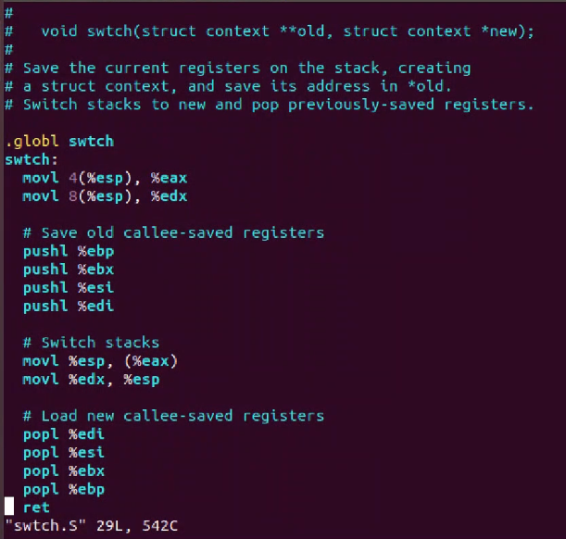

In xv6, we only need to save 5 registers, which are pushed onto the stack of the current process. Then the 5 registers pushed onto the stack of the process to be switched to are popped into the registers; thus we now have a context switch from one process to another.

Then when the user process returns (thus, after the switch statement returns), the swtichkvm() is called 🡪 switch from user page table back to the kernel page table (aka: switch from user virtual memory (uvm) to kernel virtual memory (kvm)).

Then continue running (loop again) the scheduler() function’s infinite loop to select and run another process, and reinitializing c🡪proc = 0.

ptable = process table. Here is part of the definition:

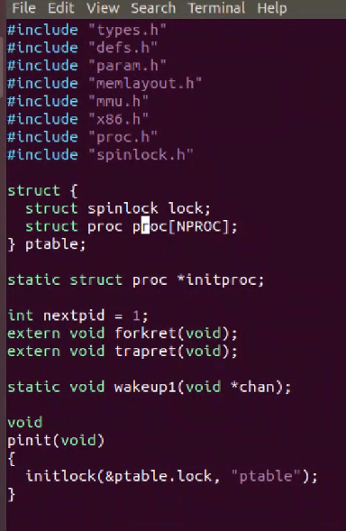

NPROC == 64; in XV6, you can only create a maximum of 64 processes. It is found in the param.h header file:

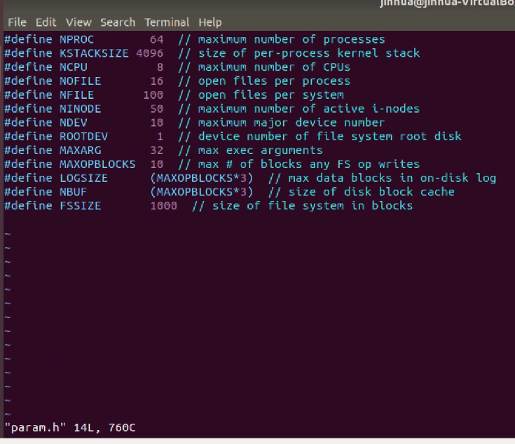

ptable struct has a lock variable that must be acquired before updating the fixed proc[NPROC] struct array.

In the proc[NPROC] struct array, it has all information about each process.

Our job is to change the scheduler() function in the proc.c file from a round robin scheme to lottery.



Notice above: we initialize c🡪 proc = 0 to indicate there are no user processes running.

Primary objective is to change the small code under “//Loop over process table looking for process to run”, which is a round robin scheme, and change it to lottery scheduling. Everything after that (the context switching to the selected process, etc.) can stay as it is.

Make sure to leave the enable interrupts line in the code.

First, **outside** of the *second* for loop, iterate through entire process table (ptable) to count total number of tickets for processes in the RUNNABLE state. The outer for(; ;) should not have code written to it as it is what will infinitely loop to process user processes or wait for a user processes to process.

Second, below the line of code from the above first step, add the winner as a function of a random number generator to generate a number between 0 and total tickets (which was just acquired from the first step) by using a modulus operator. It is good to add +1 to the random number function, since sometimes the total tickets in the system can initially be or later be 0 and we don’t want a divide by 0 error; so we can avoid that issue by adding 1 (since rand() % 0 is throws a divide by 0 software voluntary interrupt error.).

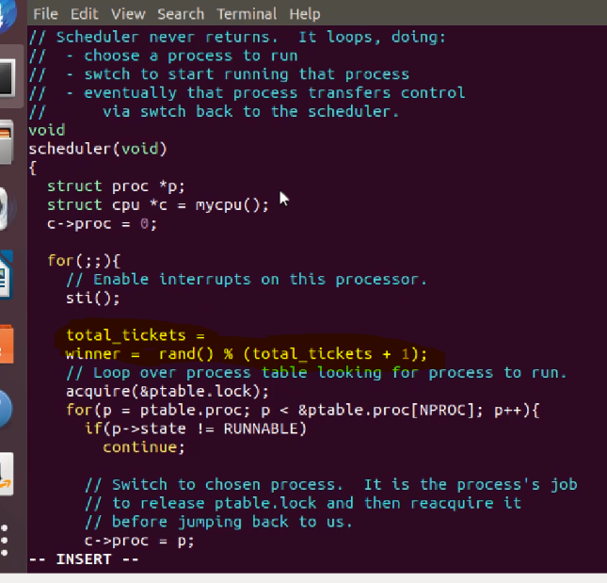

Then, following the logic how finding the winner, you implement that logic inside of the second for loop: continue to count all runnable processes (sum them) until you find a value where number of tickets a process has is >= winner value, as shown in the example:



You can use cprintf statement to see which process gets scheduled and about to run, including each tick (cpu cycle) as it continues to be ran:

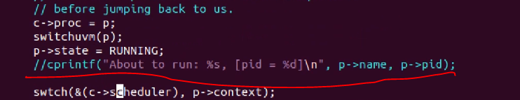

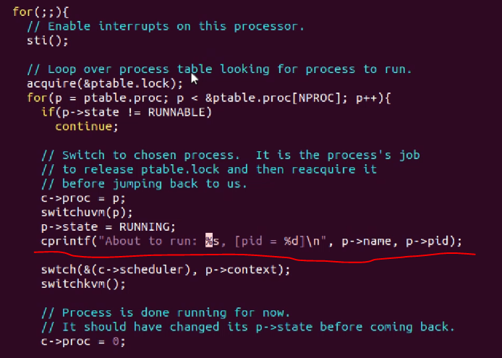

Example of output from the print command:

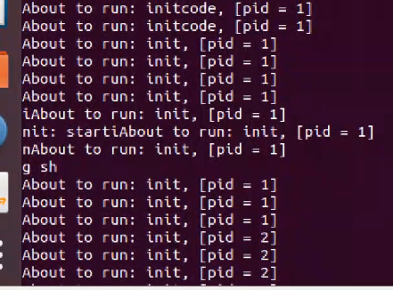

Note, you can compile and run XV6 in the same terminal via this command (to quit xv6, press control+a x, that is press Ctrl+a together and then release. Then press the ‘x’ key):

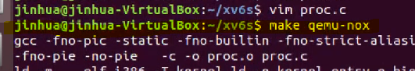

## fork() system call function (proc.c)

fork() system call creates a new process, and copies everything from its parent.

Allocate a new process, called np.

we copy the parent’s process state to the new process (the child process).

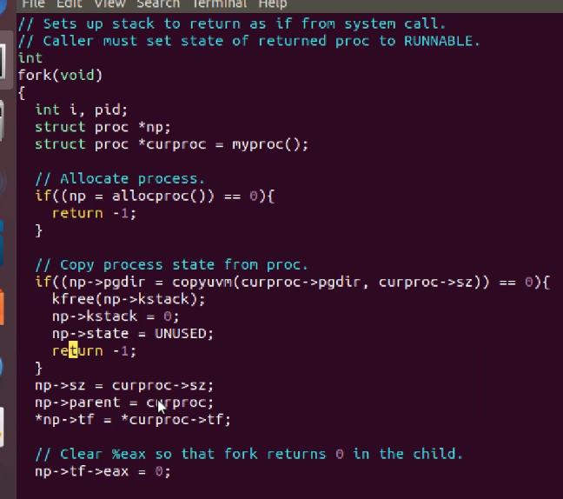

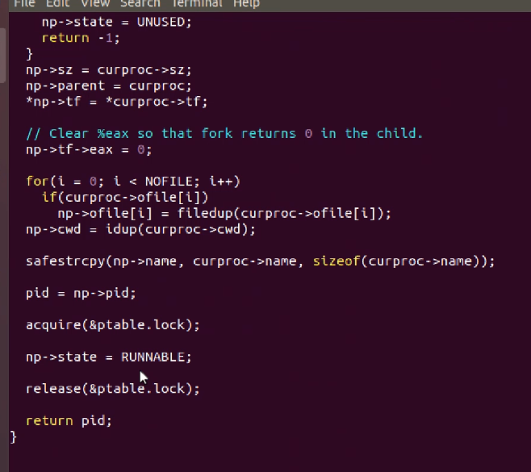

So remember for this project, we need to update 2 things: number of a tickets for a new ticket, where default is 10 tickets – but for a child process via fork, child tickets should = parents tickets; AND we need to update the new process numticks = 0:

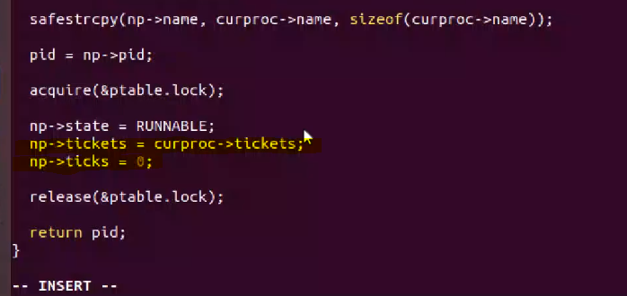

## userinit() function (proc.c)

Need to make similar changes made to fork() function in the userinit() function.

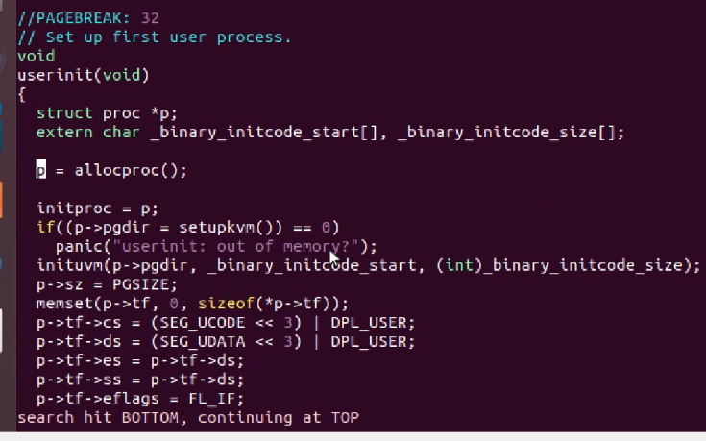

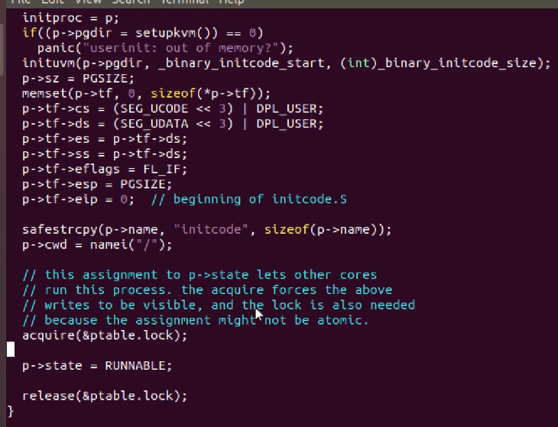

Here, we need to assign number of tickets to the newly created process; but this time, set it to the default = 10, and set numticks = 0. Do it in the same location as with the fork() function (circled in red):

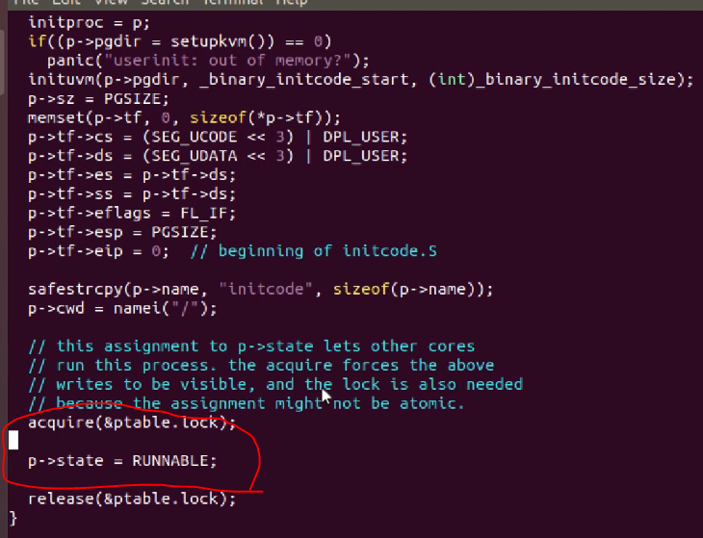

## getpinfo() function (sysproc.c)

You need to add an entry for set tickets and yield and getpinfo functions in sysproc.c

getpinfo() needs to iterate through the process table to get information (state, id, numtickets, num ticks) about all processes that have a state that is **not** UNUSED. (so, runnable or running; get the information).

Call the getpinfo function at end of scheduler function:

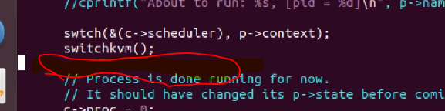

Add the implementation here:

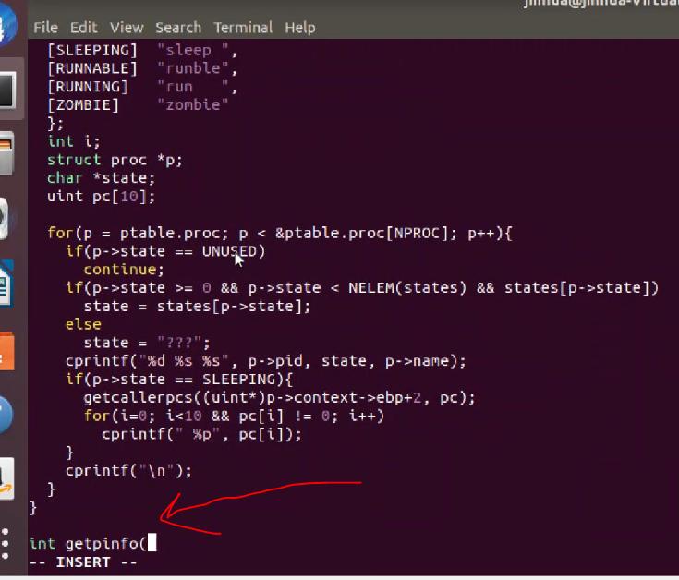

Follow part of the logic from the above function which checks if a process is UNUSED; if not UNUSED, then get info.

## lotteryTest.c

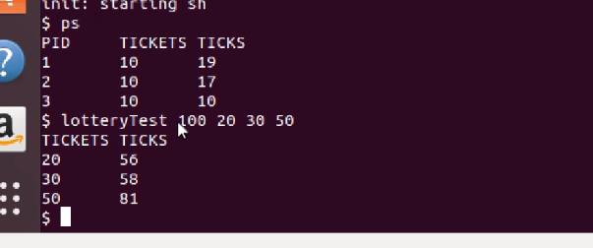

Notice, number of ticks each process runs for is roughly proportional to the number of tickets each process has. Also, even though first parameter is number of ticks = 100, you notice that total number of ticks summed up for all processes is about 200 = double the input. This is because xv6 runs two CPUs.

So if you input 200 for number of ticks to run a set of processes with set ticket values, the total ticks will be about 400 since **each** CPU runs about 200 ticks.

Proportionality with respect to number of tickets and total ticks will become more accurate if you input longer number of ticks and more the more processes you run in the system (need at least 4 processes):

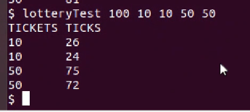

## random.h – concerning the scheduler() function

If we want more controlled but more random pseudo random, we may want to call srand() function which can take a parameter that determines the random value generated; the passed in parameter can be based on current time of day or both date and time (use cmos time):

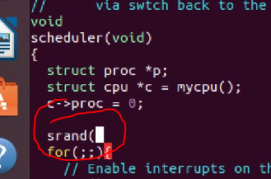

Otherwise, you can pass in a value to purposely generate the same pseudo-random values for more controlled initial testing, or just call the rand() function which uses current state of the system to generate pseudo random values.

## (trap.c)

Question: when we context switch to a user process and change mode to user mode and run the user process, how do we switch back to the kernel again (on yield, interrupt, system call, etc.)???

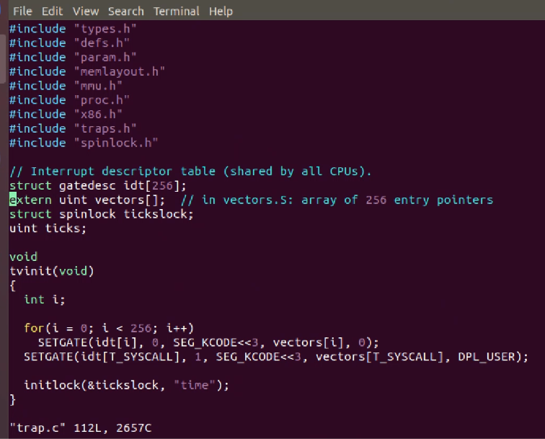

There are all the different kinds of interrupts in trap.c

For example, software interrupts, such as system calls.

But normally when we switch back to kernel from user mode (and a user process) there is a yield due to a timer expiring and the process has not finished yet, so that kernel can run kernel code again (namely, the scheduler/schedule function) and context switch to another process to be ran.

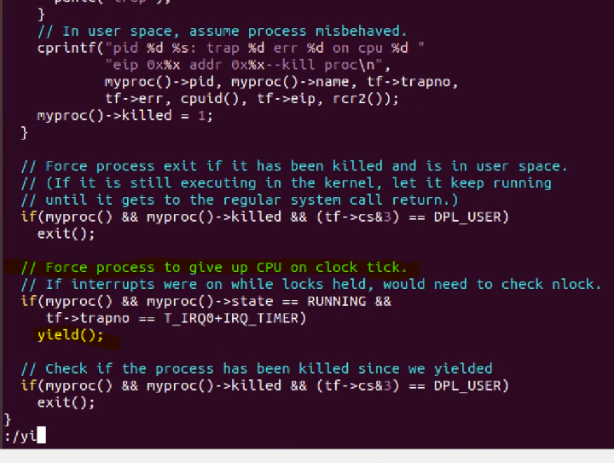

Now lets see the yield() function, which is in (proc.c)

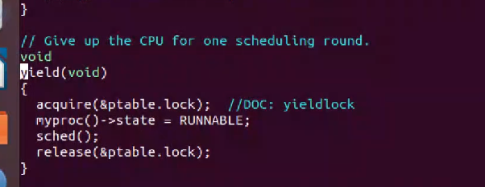

Process will be changed from running state to runnable (ready).

Also from the sched() function (also in proc.c) it will end up calling swtch() function to do a context switch from current running user process (or whatever type of process calls yield) to the cpu scheduler (a kernel-level function; thus this is a context switch from user mode to the kernel). And then as noted in other places in this document, the kernel scheduler() function will perform a context switch to another user process:

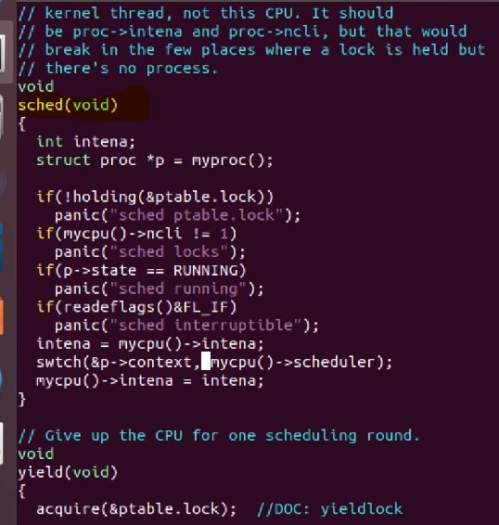

## mycpu() and myproc() functions (proc.c):

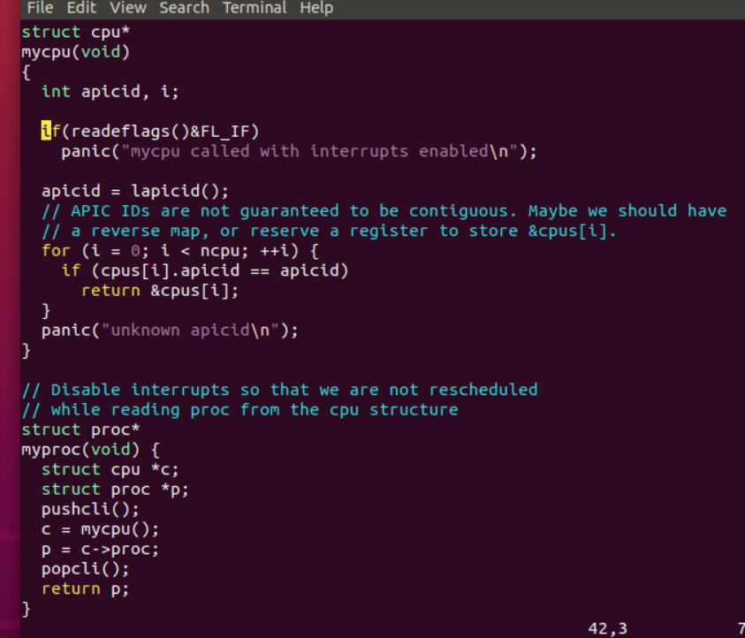

The mycpu() function gets the current information stored in a CPU registers for the currently running process and returns a cpu data type reference where the data/information is stored in memory. Then, myproc() function uses mycpu() function to acquire that reference, and then acquire specifically the proc struct (which is in the reference to the cpu struct), which is the PCB = Process Control Block data, and return a reference to the proc struct that is in the cpu struct. So both functions simply return references to global variables declared in the proc.c program, namely:

the global cpu struct variable (in proc.h):

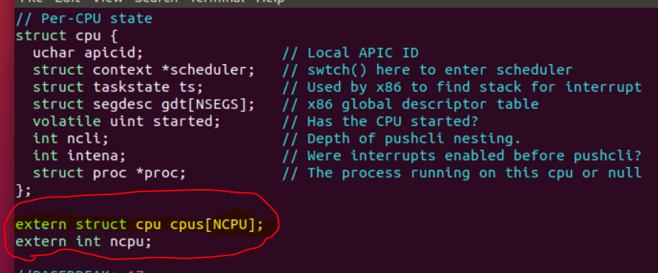

and the global proc struct variable (in ptable struct from proc.c):

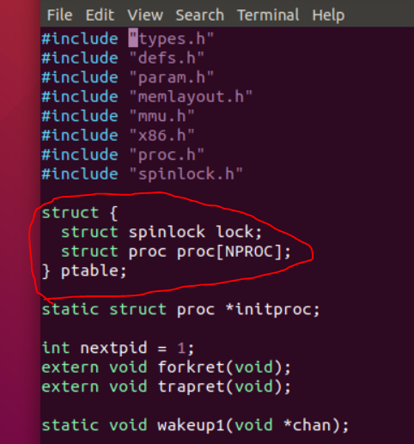

This means I can use myproc() and mycpu() to acquire the global variable references in order to use the data from a CPU and processes running in the system.

## System call flow diagrams

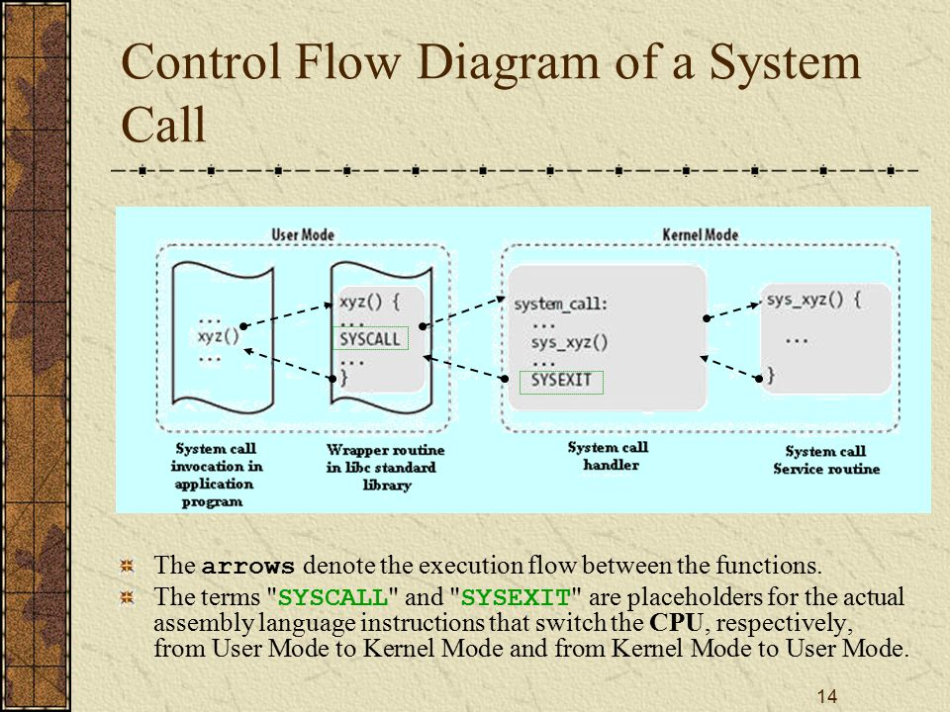

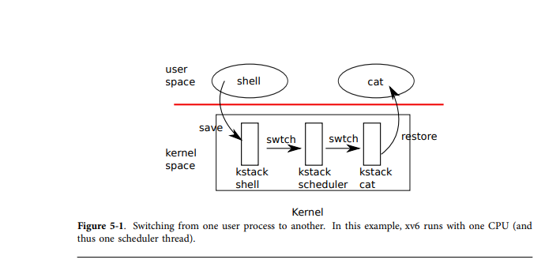

Referencing my date user and system call function from project 2:

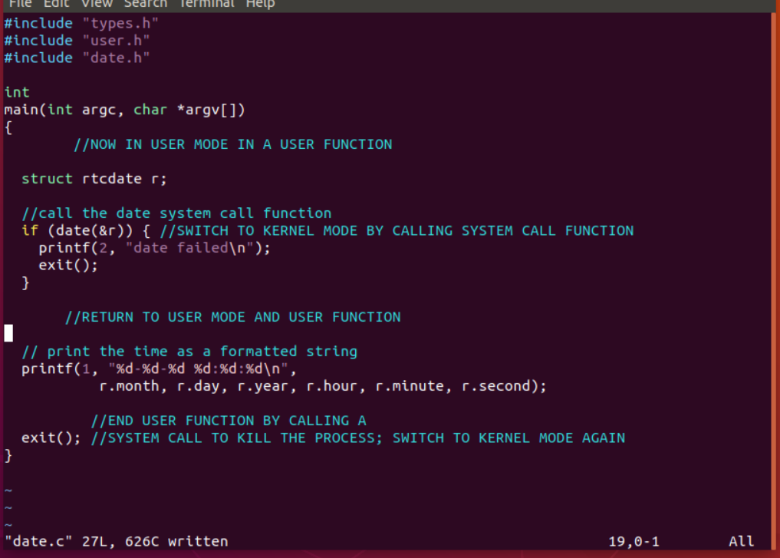

# Using vim editor

## Searching a file

When you open a file (for example: vim proc.c), type the following in order to search for a word or phrase in the file:

:/mystring (this will search the file for “mystring”

If the first match is not what you are looking for, simple type :/ to go to the next instance.

## Switch file

To edit another file with vim, simple type :e nameOfFile. This will simply exit the current file and enter to the specified file, but the file must be in the same directory as the current file.